Trauma Exposure and Sources of Traumatic Stress

Types of Organizational Trauma

Just as individuals can be traumatized, so can organizations. Organizational trauma is experienced when organizations enact, as well as act out of, traumatizing dynamics and circumstances among employees. There are four identified types of organizational trauma and the organizational behavior that often results, as described below:

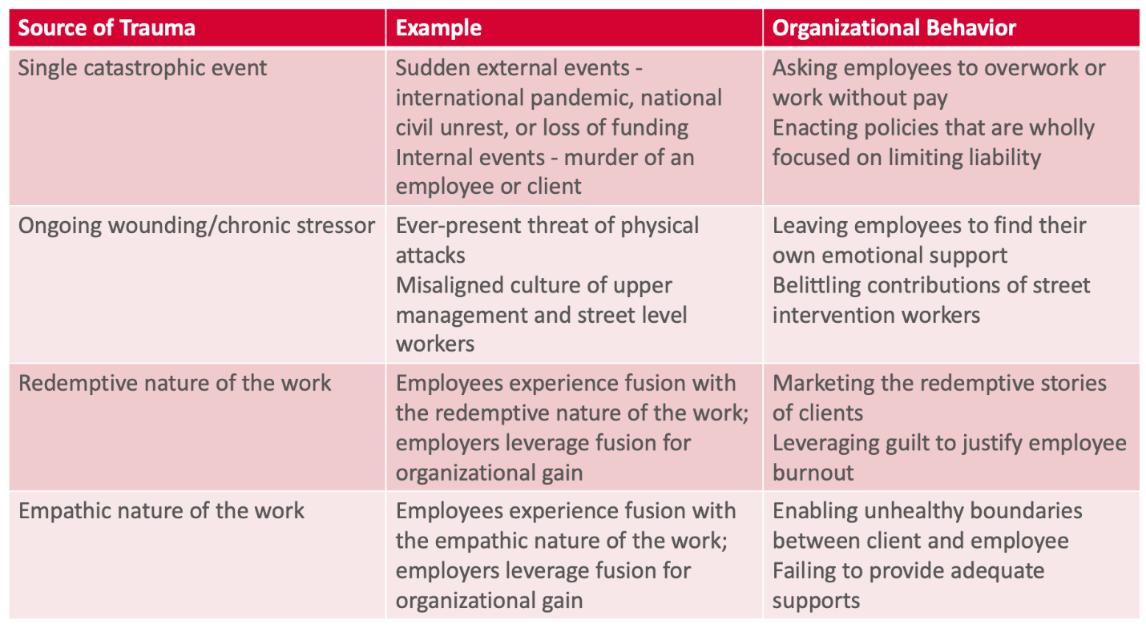

Single Catastrophic Event

Organizations must respond quickly and effectively to singular, unique events such as a global pandemic or national civil unrest. Street intervention workers are not often included in the decision making around organizational responses to catastrophic events, and these responses are frequently more focused on limiting liability than ensuring that any response was still in line with their organizational mission.

Ongoing Wounding/Chronic Stressors

Street intervention workers endure chronic wounds and stresses inflicted by structural misalignment between administrators and frontline staff. Delegitimization, devaluation, and disrespect are common themes of these chronic wounds and often felt in the realms of compensation, decision making, and professional advancement.

"I guess with like upper management…I wish they understood the work that we're doing and what it does to us. And I feel like there's…very little type of compassion, empathy, or trying to use any restorative justice principles or framework to understand the type of work that we're doing, because I feel like to them, everything is just numbers essentially."

Redemptive Nature of the Work

The work of street intervention is strongly tied to a redemptive narrative. Street intervention workers see their work as an opportunity to redeem the personal trauma of their past, give back to the community, and help clients avoid the broken path street intervention workers know too well. The redemptive narrative works both ways for participants: their work redeems themselves as much as it does their clients, yet street intervention workers are quickly overwhelmed with the immense needs in the communities they serve and their limited time and resources. Organizations that leverage this inclination for organizational gain cause stress and wounding.

"I think I'm always on edge when I know that something in the neighborhood's happening. And, um, I always get like a lot of—a lot of fear, too. Like, you never know who's gonna be next. It's more of the fear of like, 'Please let it not be that person,' or, 'Please, let it not be one of our own,' or, 'Please,' you know, like-like I just don't wanna get the phone calls because they're so— And even if it's not me being the first responder, like even just my coworkers, even hearing their experience with it. Like that makes it even heavier too because we carry so much afterwards.”

Empathic Nature of the Work

Street intervention workers rely on their relational skills to deliver services to clients. Street intervention work is empathic by design and workers feel strong pressure to integrate themselves into the lives of their clients. Because their clients are on the streets 24/7, street intervention workers see their role as being available 24/7. Organizations lean into this expectation by delivering both explicit and implicit reinforcements and rewards to street intervention workers for being “on call.”

"I guess with like upper management…I wish they understood the work that we're doing and what it does to us. And I feel like there's…very little type of compassion, empathy, or trying to use any like restorative justice principles or framework to understand the type of work that we're doing, uh, because I feel like to them, everything is just numbers essentially."

Food for Thought

  - The categories of organizational trauma described above provide a starting point for street intervention workers to filter their organizational experiences. While violence exposure via street intervention work may be inevitable, there is substantial flexibility in how organizations function. In each of the categories, staff members can reflect on opportunities to shift practice in ways that optimize support for workers and promote worker wellness. The questions listed below are a starting point and not an exhaustive list of questions.
  - Single Catastrophic Events
    - The COVID-19 pandemic is at its two-year benchmark and organizations are continually adapting to public health mandates that require revisions to social service provision. How has the pandemic impacted street intervention programming? How has the team adapted to the circumstances, and has the organization provided an opportunity for staff to discuss the impact of the pandemic on their program and team’s wellbeing?
  - Chronic Stressors
    - Are there recurring organizational stressors that impact street intervention workers? Examples may include funding, having space to run programs, staffing shortages, insufficient program resources to support clients, etc? It is encouraged that staff create a list of these stressors (and make sure they are associated with their experience within the organization vs. their street intervention experience)
    - Examining this list, what ideas does the team have to amend practice to mitigate some of the stress experienced? It is important that this list and the subsequent recommendations are shared with supervisors and organizational administration
  - Redemption
    - To what extend does the team identify with the redemptive nature of street intervention work? Are there staff members that describe their involvement in violence intervention work as part of their own personal redemption?
    - Are there ways in which staff feel that this redemptive path is used against them within their organization? Do team members describe experiences where they feel hurt by their organization, yet they endure these experiences out of their desire to help/ save others?
  - Empathy
    - Street intervention workers repeatedly described their work as “24/7” without clear start or end times. As first responders involved in violence reduction work, some aspects of this are inevitable. However, it is possible that organizations exploit workers empathic drive and promote work dynamics that lead to burnout among staff. As a team, discuss whether or not this reflects the team dynamics and opportunities to practice a healthier work/ personal life balance. Subsequently, are there ways in which organizations can critically examine work patterns/ ‘unofficial’ practices that contribute to worker burnout? What ideas do staff members have to prevent this from happening?

Vivian, P., Cox, K., Hormann, S. D. L., & Murphy-Kangas, S. (2017). Healing traumatized organizations: Reflections from practitioners. OD Practitioner, 49(4)

