Trauma Exposure and Sources of Traumatic Stress

Common Experiences of Personal Trauma

Street intervention workers have an extensive history of past trauma and often draw on their personal past trauma as they work with clients’ present trauma​. Types of adverse life experiences include abuse, neglect, and household dysfunction. While their personal experience can help street intervention workers engage their clients, it can also cause distressing thoughts and unwanted reactions when street intervention workers re-experience their past traumas. Symptoms of being triggered are:

- Reexperiencing the past trauma as if it were happening today
- Avoiding the trigger, even if it’s benign
- Having unstoppable negative thoughts, like “It’s all my fault,” or “I’m not good enough”
- Being suddenly irritable, anxious, angry, sad, or moody
- Feeling hyperalert, hypervigilant, or ready to “fight or flee”

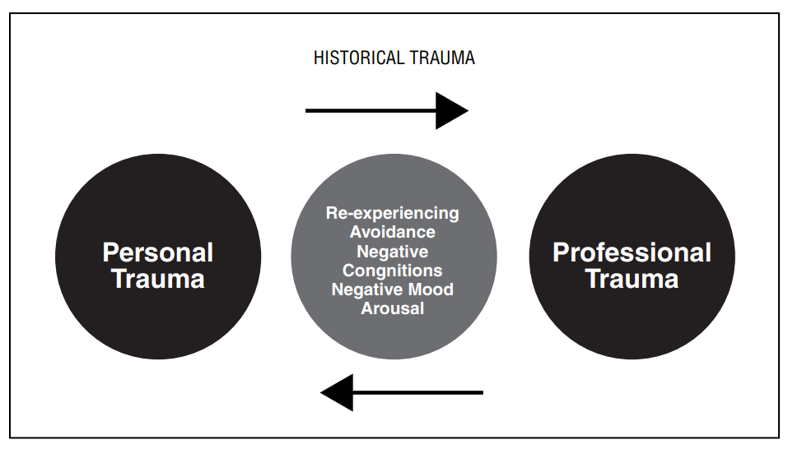

Furthermore, staff may be experiencing parallel distress in their personal lives in addition to the stress involved with street intervention work. As discussed in other worksheets, they may have family issues, physical health concerns, or be involved in substance use recovery services among other challenges. The emphasis of this worksheet is to remember that in addition to the traumatic stress involved in street intervention work, staff may be simultaneously navigating distressing personal challenges.
Street intervention workers identify their work as one way they cope with their past trauma. They find meaning in helping clients escape the cycle of trauma, and the rich relationships they develop with colleagues can be healing. However, work can become an unhealthy coping mechanism if becomes a way to avoid areas that need attending.

Food for Thought

  - Some staff may want to separate their personal circumstances from their professional work, whereas others need for their team members to be aware of their personal circumstances. Depending on the comfort level of staff, it may be beneficial for street intervention teams to provide both individual-level and group-level check-ins related to staff wellbeing outside of the workplace.
    - In both individual supervision and group check-ins, are there opportunities provided for staff to share any challenging personal circumstances they are navigating?
    - To what extent does the organization encourage and support staff wellbeing when they are not working? This doesn’t necessarily mean telling them not to work, but rather to explore social, emotional, and physical wellness opportunities outside of the workplace (riding a bike, watching a movie, visiting a park, spending time with extended family, etc.)
  - As it relates to forms of historical/past trauma, organizations can provide training or invite speakers to reflect on how past trauma impacts one’s current functioning. It is encouraged that administrators, supervisors, and staff reflect on the extent to which they observe staff members operating from a place of previous trauma. Awareness of the presence of the past is a starting point to advance worker wellness.
    - For example, if a staff member is a sexual assault survivor, how does this experience impact their ability to support a client who is experiencing intimate partner violence?
    - If a staff member is experiencing frequent conflict with their supervisor, are there past life experiences where this staff member experienced harm from an authority figure in their life (parent, elder, correctional officer, etc.?)

