Trauma Exposure and Sources of Traumatic Stress

Common Experiences of Professional Trauma

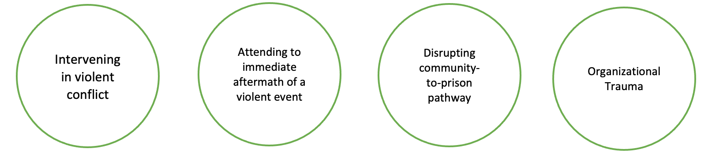
Street intervention workers describe four major types of trauma experienced on the job: intervening in violent conflict, attending to the aftermath of a violent event, disrupting community-to-prison pathways, and organizational trauma. This worksheet describes the first three forms of professional trauma. Organizational trauma is discussed in separate worksheet.

Intervening in Violent Conflict

Acting as “first responders” to incidents of violence in their prescribed communities, street intervention workers show up at crime scenes, responding to shootings and homicides, as well as mediating conflicts that could escalate into potentially fatal situations.

Attending to the Immediate Aftermath

Many violent conflicts end in death, which often leads to retaliatory acts of violence. Street intervention workers attend to the aftermath of a violent incident in their communities through mediation, attending funerals, coordinating vigils, and providing resources to surviving family members. Street intervention workers accompany grieving families and may have to absorb the anger and frustration of family members and friends who believe that ‘more could have been done’ to prevent their death.

When you lose a participant, it has some kind of profound effect upon you to the point you start questioning yourself…'Am I in the right field? Am I doing the right thing?' You know, these people [are] just losing their lives based on your trust and whatnot, and to see them get hurt in the process, it [has] a toll on you…But what keeps driving me, motivating me to come back is the people because I would like to do what I can to help them to get a chance to have a better life.

Disrupting Community-to-Prison Pathways

Street intervention workers are often system-survivors and assist their participants in navigating different forms of criminal legal contact and involvement. This work can be retraumatizing for street intervention workers, as they have often been through this process in their personal lives, either on their own or on behalf of a family member or friend. Forms of criminal legal contact include: police stops, advocating for clients being detained at police stations, attending court hearings, visiting clients in jail and prison, and assisting clients in managing community supervision (probation or parole) requirements.

We're always going to be Black and Brown to law enforcement. We're always going to look like a gang member to the rival gang. We're always going to be ex-felons, or former incarcerated people that people look at with less regard, or don't take our words seriously. Or see our line of work as insignificant, or as really a consequence of not being able to do something more and better with our lives.

Food For Thought

  - Most organizations are aware of the traumatic effect of violence exposure in street intervention work, however this research provides an opportunity to better understand what aspects are hurting staff the most. Using the themes discussed above, it is recommended to have team discussions around each one of these topics. The questions below are a starting point and not an exhaustive list in each of these areas of professional trauma.
  - Intervening in Violent Conflict
    - What aspects of mediating conflicts cause you the most stress? How do you experience this stress? In these situations, what would help you feel safer and process what you experience?
    - What safety measures do you take when conducting mediations? Do you have any recommendations to enhance your sense of safety and that of your team members?
  - Attending to the Aftermath
    - What are the most challenging parts about assisting grieving families after a homicide occurs? Do you feel that you have adequate training and support to assist these families?
    - How do you process the loss of a client as a team? Do you have personal resources outside of work to help you process loss?
    - Are there any resources that could assist you in your interactions with grieving families?
  - Disrupting Community to Prison Pathways
    - How frequently do you interact with police, and what are the nature of these interactions within the context of your professional work? Are there particular elements of these interactions that are stressful to you, and is there anything your team and/ or organization could do to alleviate this stress?
    - How frequently do you interact with probation or parole officers during your work? Are there particular elements of these interactions that are stressful to you, and is there anything your team and/ or organization could do to alleviate this stress
    - How frequently do you conduct visits with participants in jails or prisons? How do you feel during and after these visits? Are there supports that you need to support your engagement with incarcerated clients?

