Moving Towards Organizational Best Practice

Trauma and Burnout in the Workplace

Alongside the trauma narratives shared by street intervention workers, they frequently used language consistent with burnout. Emotional exhaustion, cynicism about funding and role requirements, and frustrations with personal effectiveness underlay participant recommendations for changes in the workplace. The complex interweave of trauma and burnout is beyond the scope of this study, but the literature on burnout provides a useful roadmap towards a trauma-informed workplace. Burnout was first conceptualized around six domains of work life: workload, control, rewards, community, fairness, and values. Later research added additional domains such as resources, meaning, and work-life integration.

The research team analyzed the narratives of street intervention workers and found that their description of burnout aligned with seven drivers of burnout outlined in existing literature.. These domains of burnout are applicable across organization size and budget and organizations can mitigate the effect of drivers regardless of its resources.

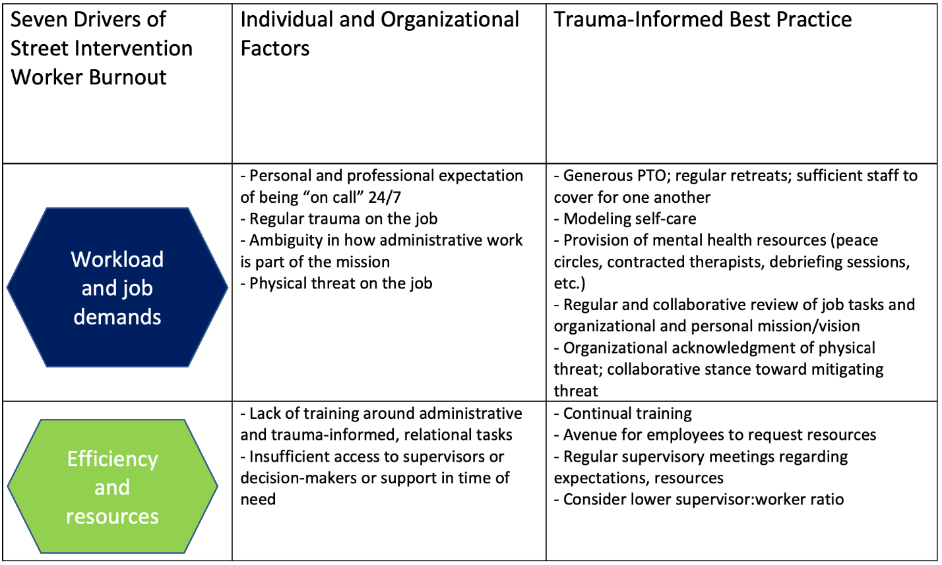

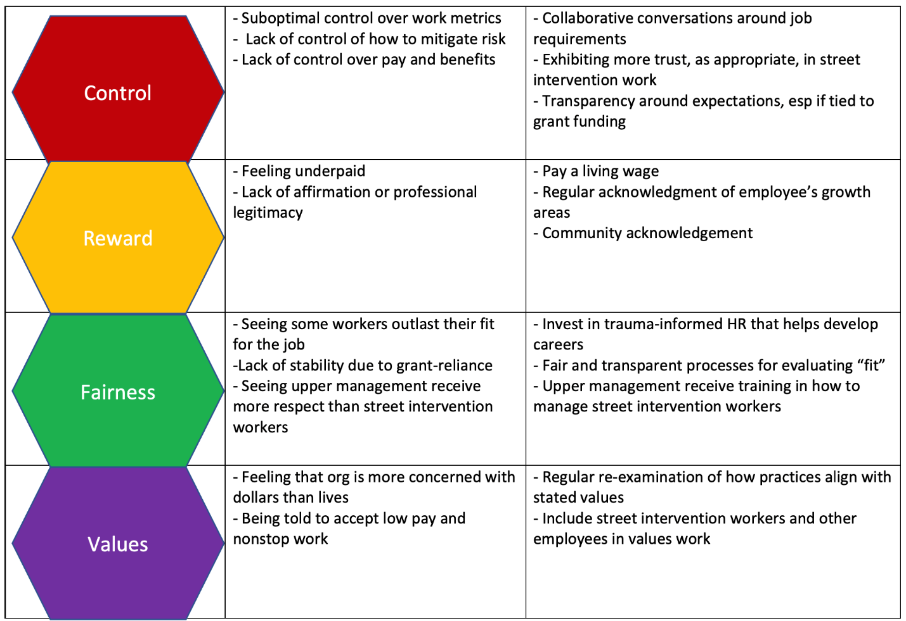

Maslach, C., & Leiter, M. P. (2017). Understanding burnout: New models. In C. L. Cooper & J. C. Quick (Eds.), The handbook of stress and health: A guide to research and practice (pp. 36–56). Wiley Blackwell.
Maslach, C., Jackson, S. E., & Leiter, M. P. (1997). Maslach Burnout Inventory: Third edition. In C. P. Zalaquett & R. J. Wood (Eds.), Evaluating stress: A book of resources (pp. 191–218). Scarecrow Education.
Shanafelt, T. D., & Noseworthy, J. H. (2017, January). Executive leadership and physician well-being: nine organizational strategies to promote engagement and reduce burnout. In Mayo Clinic Proceedings (Vol. 92, No. 1, pp. 129-146). Elsevier.

